TattvaCo — Phase 1 Wireframe Design
We’ll design the actual product experience here, screen by screen, using the agreed PRD and Information Architecture. This is the wireframe specification, not another prompt.
The objective is to make TattvaCo feel like a cultural discovery product—not a generic AI chatbot, a tourism app, or a digital encyclopedia.

1. Product experience and navigation
The core user journey is:
Discover
Find something culturally intriguing
Explore
Enter a story with context
Understand
Follow relationships and evidence
Connect
Ask questions and go deeper
Continue or share
Continue the current exploration or share a story or connection with a link. No saved library or persistent discovery trail in Phase 1.

Proposed primary navigation
For mobile, use a persistent bottom navigation with four destinations:
Discover
Explore
Ask
Settings
Design recommendation, not a locked decision. Connections should be accessible directly from stories and answers, rather than needing a separate bottom-nav destination.

2. Screen 01 — Sign in / Create account
Purpose: Authenticate users before they enter the main discovery experience, as currently agreed.

TattvaCo
Discover the relationships, context and living meaning within India's cultural universe.

Begin your discovery
Sign in or create an account to explore.
Continue with Google Continue with Apple
Email address
Continue with email
Phone number
Continue with phone
By continuing, you agree to the applicable Terms of Service and Privacy Policy.
Required states: default, invalid input, verification pending, incorrect or expired verification code, authentication failure, loading, and successful authentication.
Important: Google and Apple are authentication options in the design, not connected or functional sign-in providers in this wireframe.

3. Screen 02 — Language selection
Purpose: Select the language for the core discovery experience.

Choose your language
Explore stories, ask questions and discover connections in your preferred language.
Englishहिन्दी · Hindiಕನ್ನಡ · Kannadaമലയാളം · Malayalamবাংলা · Bengaliதமிழ் · Tamilमराठी · Marathiతెలుగు · Teluguગુજરાતી · Gujaratiਪੰਜਾਬੀ · Punjabiଓଡ଼ିଆ · OdiaContinue in selected language
All 11 launch languages are intended to support the full core journey, subject to language-specific quality validation.
Open decision: whether the language choice persists across sessions or is selected again on each visit. The screen must also handle content that has not yet passed quality validation in a selected language.

4. Screen 03 — Home / Discover
This is the most important screen in the MVP. It should make the product's value obvious within seconds and offer three equally understandable entry points: browse, ask, or discover a connection.

TattvaCo
India, connected through culture

There is more to every story.
Explore the traditions, ideas, people and places that shape India's cultural universe.

What are you curious about?
Ask a question about Indian culture, history, traditions or their connections.
Why do different Indian traditions use the lotus as a symbol?
Ask in your selected language

Discover a city
View all 6

Varanasi
Rituals, rivers and living traditions

Jaipur
Craft, architecture and royal histories

Hampi
Empire, landscapes and monuments

Kochi
Coastal exchange and cultural encounters
Kolkata and Madurai appear in the full city directory. These descriptive labels are illustrative and need editorial review.

Follow a connection
The lotus across traditions
Explore how a shared symbol can carry different meanings across religious, artistic and historical contexts.
Explore related stories
Discover
Explore
Ask
Settings

Home screen requirements
- The question input must be prominent without making the rest of the product feel like a chatbot.
- City and connection cards must lead to meaningful content, not empty category pages.
- Show only stories and connections approved for the selected language.
- No location tracking, personalised recommendations based on persistent profiles, or fake popularity rankings.
- Any images used in the shipped product must have appropriate usage rights, accurate captions and editorially verified relevance.
Primary action: ask a question or open a discovery item.
Secondary action: browse the full city list.

5. Screen 04 — Explore all cities
Purpose: Provide a clear entry point into the six-city pilot without implying that TattvaCo is a travel-booking product.

Explore places
Discover the cultural stories and connections rooted in these places.
Search the six pilot cities
Varanasi
River traditions, ritual and sacred geography
Jaipur
Architecture, crafts and courtly histories
Hampi
Monuments, empire and material culture
Kochi
Maritime exchange and cultural encounters
Kolkata
Literature, art and intellectual movements
Madurai
Temple traditions, poetry and urban history
Wireframe note: descriptions above are illustrative content themes, not approved claims or final city positioning.
Behaviour: selecting a city opens its city overview. Searching filters the six pilot cities. If a city has no approved stories in the selected language, explain the limitation instead of showing a blank page or silently substituting another language.

6. Screen 05 — City overview
Purpose: Give the user a coherent cultural entry point into a city and surface its flagship stories and connections.

PILOT CITY

Varanasi
Explore the relationships between place, ritual, history, artistic expression and living cultural practices.

Start with a story
Choose a curated exploration, then follow the connections that interest you.

Flagship stories
The ghats: architecture, ritual and river
An exploration of how built spaces, water and cultural practices intersect.
Story · Context · Sources · Connections
Music and the cultural life of the city
Explore musical traditions, lineages and the contexts in which they developed.
Story · Context · Sources · Connections
Many meanings of a sacred place
Understand how different communities and traditions describe a place.
Story · Perspectives · Sources · Connections
Open a flagship story
The actual city overview should contain approximately three to four flagship stories once the editorial inventory is approved. The titles above are design examples; they are not a final editorial catalogue.

7. Screen 06 — Flagship story detail
This is the core value-delivery screen. The experience should help someone understand a subject and its significance, rather than simply scroll through a long article.

VARANASI · FLAGSHIP STORY

The ghats: where architecture meets the river
An introduction to the relationships between a riverfront, public space, ritual practice and urban history.

The story
Begin with a clear narrative that explains what the subject is, where it belongs, how it developed and why it matters.
Use specific examples and explain the relationship between physical spaces and the cultural practices associated with them.

Why it matters
Explain the significance of the subject for relevant communities, historical contexts and contemporary cultural life, without assuming that every person or tradition shares the same interpretation.

What the evidence supports
Present important claims alongside the sources that support them. Distinguish documented evidence from traditional accounts and scholarly interpretations.
Source details must be linked to the claims they actually support.

Explore the connections
Architecture and ritual
Explore the relationship between built spaces and cultural practices.
River and sacred geography
Explore how a river is understood in different cultural contexts.

Go deeper
Ask a follow-up question about this story.
Example: How have the uses of these riverfront spaces changed over time?
Shareable link · Report a problem

Required story structure
- Title, context and introduction.
- Narrative explaining the subject.
- Historical, geographical and cultural context where relevant.
- Significance, including differing perspectives where appropriate.
- Evidence, tradition and interpretation clearly distinguished.
- Claim-level source references.
- Curated related connections with an explanation of each relationship.
- Follow-up question entry point.
- Share and report actions.
Do not show a generic AI confidence percentage as a substitute for evidence. Uncertainty should be expressed in meaningful language, such as “sources differ,” “the evidence is limited,” or “this interpretation is contested,” where appropriate and supported.

8. Screen 07 — Ask TattvaCo
Purpose: Let users ask open-ended cultural questions and receive answers that connect ideas, explain context and make supporting evidence inspectable.

Ask TattvaCo
Explore a question. Follow the context. Check the sources.
YOUR QUESTION
Why does the lotus appear in different Indian religious traditions?
TattvaCo's response
The lotus has been used in several Indian religious and artistic traditions, but its meaning depends on the context. Similar imagery does not necessarily imply identical beliefs or a single shared origin.

Understand the context
In a specific work of art or text, interpretation depends on the period, tradition, depicted figures and available historical or textual evidence.

Explore related perspectives
The lotus in Buddhist traditions
Explore interpretations supported by relevant texts and historical sources.
The lotus in Hindu traditions
Explore how meanings vary by deity, text, artwork and historical context.
The lotus in Jain art and tradition
Examine relevant examples rather than assuming the same meaning across traditions.

Sources for this answer
Relevant sources should appear here, linked to the claims they support.
Ask a follow-up question…
Responses in your selected language
The example answer and related topics above are illustrative wireframe copy, not a completed, source-verified production answer.

Q&A behaviour
- Accept open-domain cultural questions.
- Retrieve relevant external sources.
- Present direct answers before deeper detail.
- Explain relationships instead of simply listing related entities.
- Provide source references at claim level where feasible.
- Distinguish established evidence, traditional accounts, scholarly interpretations and unresolved disagreement.
- Offer follow-up questions and connection links without forcing a fixed conversation path.
- Never imply that a model-generated answer has received editorial approval unless it has.

Required answer states
Generating
Show that the answer is being prepared; don't fabricate partial citations.
Answer available
Show answer, supporting sources and relevant connections.
Conflicting evidence
Explain the disagreement and represent credible perspectives fairly.
Insufficient evidence
Say what could not be established; offer a narrower question or available sources.
Retrieval failure
Explain that the answer could not be completed reliably and provide a retry path.
Sensitive or high-risk topic
Apply the approved stricter checks and fallback behaviour before displaying a response.

9. Screen 08 — Source details
Purpose: Make trust inspectable. Users should be able to understand where an important claim came from, what the source says and what it does not establish.

Sources and evidence
Sources related to the answer about lotus symbolism.
Source title
Author or institution · Publication details
Source type: to be classified

Claim supported
Identify the exact claim this source supports and the relevant passage, page or section when available.
Limitations: explain what the source does not establish or where interpretation is required.
Open original source ↗

How to interpret the evidence
A primary source, academic publication, official record or specialist work can be appropriate for different claims. Source type alone does not guarantee accuracy or relevance.

Different interpretations
Where credible sources disagree, show the relevant positions and their supporting evidence rather than presenting one interpretation as settled fact.
Report an inaccurate source or unsupported claim.
Functional requirements
- Every source link must resolve to the intended source.
- Claims must not be attributed to sources that do not support them.
- Distinguish the source's original content from TattvaCo's interpretation.
- Make source limitations and disagreements visible.
- Handle inaccessible, removed, or incomplete sources explicitly.
- Do not fabricate publication details, quotations, page numbers or source links.

10. Screen 09 — Cultural connection detail
Purpose: Explain why two or more cultural subjects are meaningfully related, rather than displaying a list of superficial associations.

Explore a connection
Cultural subject A
Cultural subject B
Illustrative relationship diagram

What connects these subjects?
Describe the specific relationship, the historical or cultural context in which it matters, and the evidence supporting the connection.

The relationship
Explain whether the connection concerns shared imagery, historical exchange, a documented influence, a comparable practice or a different kind of relationship. Do not treat these categories as interchangeable.

Evidence and limitations
Supporting evidence
Show the sources supporting the relationship and any important limits on the conclusion.
What this connection does not establish
For example, similar motifs alone do not prove direct influence, common origin or identical meaning.

Continue exploring
Read the related story
Explore the first subject in its own context.
Ask about this relationship
Investigate the evidence or alternative interpretations.
Share connection

Connection quality rules
Each connection needs:
- A clearly identified subject on each side.
- A defined relationship type.
- A written rationale explaining why the relationship matters.
- Evidence supporting the relationship.
- Uncertainty or disagreement labels where warranted.
- An editorially approved status before being presented as a verified curated connection.
The product can use AI to propose connections, but AI-generated associations should not automatically become approved cultural knowledge.

11. Screen 10 — Share a story or connection
Purpose: Let users share a specific cultural discovery through a link without creating a saved library or persistent personal discovery trail.

Share this discovery
STORY PREVIEW

The ghats: where architecture meets the river
Explore the cultural context, evidence and connections behind this story.

Share a link
Shareable URL
A canonical story link generated by the application
Define share-link behaviour
Sharing must not expose account information, private session context or personal data.
Important open decision: Does a shared story open directly for a recipient who is not signed in, or must they authenticate before viewing it? Authentication is required before the main discovery experience, but public shared-story access has not yet been explicitly settled.

12. Screen 11 — Report a problem
Purpose: Give users a direct way to report inaccurate cultural claims, broken citations, misleading connections or language-quality issues.

Report a problem
Help us identify an issue with this story or answer.
What is the issue?Unsupported or inaccurate claimMissing or broken sourceMisleading cultural connectionImportant perspective missingTranslation or language issueOther
Additional details (optional)
Specify report submission flow
A real implementation needs a secure submission endpoint, acknowledgement and editorial triage process. This design does not submit a report.
Required operational behaviour: reports should be associated with the affected story, answer, connection or source, and routed to an appropriate review queue. The acknowledgement should not promise a resolution time until an editorial service-level agreement has been approved.

13. Screen 12 — Settings
Purpose: Provide account and product controls while respecting the decision not to create persistent interest profiles or long-term AI memory.

Settings
Account
Sign-in method and account details
Language
Manage your discovery language
Privacy and data
Understand what data is collected and retained
Terms and policies
Read the applicable policies
Report a problem
Report a content or product issue
Account deletion, data-retention periods and the exact privacy controls must follow the approved privacy and security requirements.

14. Screen 13 — Editorial review workflow (internal, optional)
This is not part of the public B2C navigation. It is an internal operational screen that may be needed to meet the requirement for editorial approval of every flagship story and automated checks for routine AI answers.

Content review queue
Internal editorial workflow concept — not yet an approved admin product scope.
Flagship story: pending review
Pending
Review narrative, claims, source quality, cultural perspectives, connections and language quality.
Evidence
Editorial review
Language QA
Routine answer: checks failed
Blocked
Do not automatically approve an answer if a required check fails, is missing or returns an indeterminate result.
Reported cultural claim
Needs triage
Route reported issues according to severity and the editorial review process.

Recommended review record
Every reviewable content item should have:
- Unique content and version identifiers.
- Content type and language.
- Source and claim references.
- Automated-check results and timestamps.
- Editorial review status and reviewer.
- Approval or rejection rationale.
- Change history.
- Re-review requirements when a material claim, source or translation changes.
Governance rule: an AI model must not be the sole authority approving a flagship story. Routine answer automation must follow the agreed checks and blocking rules.

15. Cross-screen interaction and navigation rules
These rules apply to all the screens above.
User action | Expected behaviour
Select a city | Open that city's overview
Select a flagship story | Open the complete story detail
Select a connection | Open its explanation, evidence and related content
Ask a question | Generate a retrieved, evidence-aware answer
Open a source | Show source details and the claim it supports
Select a related story | Navigate to that story
Share a story or connection | Create or open its canonical share link
Report a content issue | Open the report flow with the affected item identified
Change language | Apply the selected language according to the approved language policy
Use browser Back | Return to the previous screen without unexpectedly losing the current exploration
Encounter unavailable content | Explain the limitation and offer a meaningful alternative

Loading, error and empty states
Every relevant screen must have these states designed before engineering begins:
- Loading: explain what is loading without displaying fabricated content.
- Empty: explain why no content is available and provide a useful next action.
- Error: explain what failed and provide a retry option where appropriate.
- Partial result: identify which information is available and what is missing.
- Unsupported language: clearly identify the limitation instead of silently mixing languages.
- Low-confidence or contested information: communicate uncertainty and relevant evidence.
- Broken source: identify the unavailable source and avoid presenting it as verified.
- Authentication expiry: preserve the user's safe return path where feasible.

16. Responsive layout rules
The product is mobile-first, but it must also work on desktop.
Mobile — primary design target
Single-column reading, large touch targets, compact navigation, stacked story cards and an accessible question composer.
Tablet
Two-column browsing where useful, more room for connection cards and comfortable reading widths.
Desktop
Wider discovery grids, readable article columns, and optional side panels for sources and connections.
Design requirements:
- Keep long-form reading columns comfortably narrow.
- Maintain visible hierarchy between the story, its evidence and its related connections.
- Never rely on colour alone to communicate confidence, disagreement or approval.
- Provide accessible keyboard navigation, focus states and screen-reader labels.
- Validate layouts and line wrapping in all 11 launch languages.
- Do not make native applications, offline functionality or PWA installation requirements for Phase 1.

17. Build priority: what comes first?
I recommend implementing the screens in this order. This is a proposed delivery sequence, not an already approved engineering plan.

1
Foundation
Authentication, language selection, responsive shell and navigation.
First

2
Discovery
Home, city directory, city overview and flagship story detail.
Core experience

3
Intelligence
Ask flow, retrieval-backed answers, source inspection, and curated connections.
Core intelligence

4
Trust and operations
Reporting, error handling, editorial workflow, privacy controls and language QA.
Release readiness

18. What must be settled before engineering implementation?
The wireframes establish the intended experience, but several product decisions still need to be locked.
Decision | Recommended next action
Access to shared links | Decide whether recipients can read shared content before signing in
Language persistence | Decide whether language is remembered between sessions
Language quality gates | Define acceptance thresholds and accountable reviewers for all 11 languages
Routine AI-answer checks | Specify the checks, thresholds and behaviour when checks fail
Sensitive or contested topics | Define topic categories, escalation and fallback behaviour
Editorial ownership | Assign reviewers and response times for content reports
Privacy and retention | Approve retention, deletion and session-context policies
Story inventory | Finalise the 18–24 flagship stories and their evidence packages
Oral and community knowledge | Establish appropriate sourcing, consent, attribution and representation rules
Performance and cost | Set response-time, availability and AI-cost targets
These decisions should not be hidden inside UI assumptions or left for a developer to invent.

19. Definition of done for the wireframe phase
The wireframe phase is complete when:
- All primary screens have defined layouts and interactions.
- Browse-first, ask-first and connection-led user journeys can be followed end to end.
- Source inspection and uncertainty handling are represented in the actual interface.
- Loading, error, empty and unsupported-language states are specified.
- Mobile and desktop layouts are defined.
- The six-city pilot and flagship-story inventory are mapped to real content requirements.
- Authentication, language, privacy and reporting behaviours have documented rules.
- Each screen can be traced to an agreed PRD requirement or a clearly labelled design recommendation.
My product recommendation: validate the Home → Story → Connection → Follow-up question journey first. It demonstrates TattvaCo's distinctive value more directly than a large number of screens or features. Then validate the Ask → Answer → Sources journey, because trust and evidence quality are central to the product.
The work above gives you the screen-by-screen wireframe specification in text. It does not mean the screens have been rendered in a design tool or that the example cultural content has passed editorial review.

TattvaCo — UI Visual Design Strategy
Objective: create a 10/10 visual identity for an AI-native cultural discovery product that feels intellectually rich, emotionally resonant, trustworthy, contemporary and distinctly Indian—without looking like a tourism app, a religious app, a government portal or a generic AI chatbot.
My recommendation is to approach this as a product design leader building a distinctive visual system, not simply choosing colours and a UI kit.
The visual language must communicate TattvaCo's central promise: discover the relationships, context and living meaning within India's cultural universe.

1. What the visual design must solve
Based on our established product direction, these are the design constraints I would use to judge every visual decision.
From fragmented information to connected understanding
The interface should make relationships between stories, traditions, places, ideas and evidence visible—not just arrange articles in a feed.
Trust without pretending to be the ultimate authority
Evidence, source attribution, uncertainty and different perspectives must be part of the interface, not buried in footnotes.
Curiosity before complexity
Users should encounter an intriguing question or meaningful connection before they encounter a wall of information.
One coherent experience across 11 languages
The design must accommodate different scripts, text lengths, reading patterns and language-specific content quality without breaking the layout.
Mobile-first, with depth available on demand
A welcoming discovery surface should progressively reveal deeper narratives, sources and connections. Desktop should add space, not a different product.
These are the criteria I would use to evaluate the five visual directions below. The rankings are my design-strategy assessment, not an objective industry award ranking.

2. Top five UI visual design directions
Ranked in ascending order: #5 is the least suitable of these five for TattvaCo; #1 is my recommended direction.
These are original design directions proposed for TattvaCo, not existing commercial design kits. Each combines a visual identity, a colour strategy and a practical component-system approach.
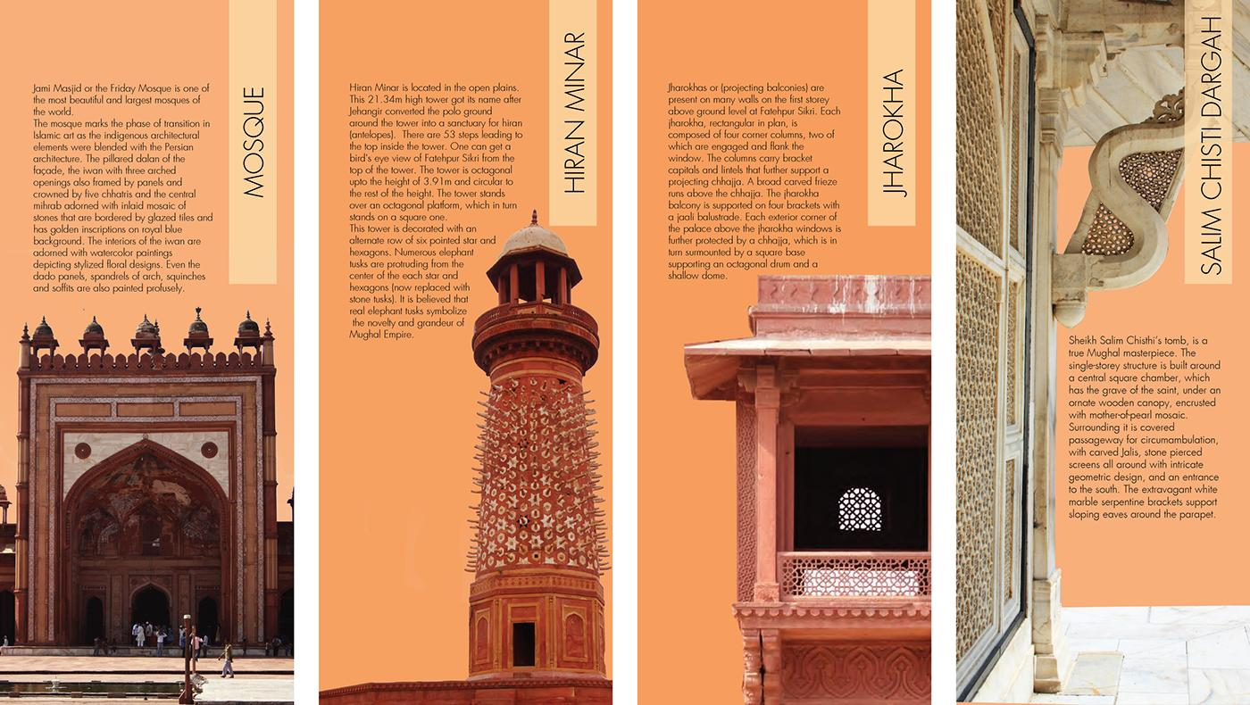
RANK #5

Heritage Minimal
Quiet, elegant, museum-inspired
Safe but less distinctive

Colour palette
Linen
#F8F4EC
Sand
#DED3C1
Terracotta
#873F32
Olive ink
#3D443B
Brass
#B9A078
Visual language: generous whitespace, restrained borders, archival photography, serif editorial headlines and understated controls.
Why it ranks fifth: it immediately signals cultural depth and craftsmanship. However, the museum-like restraint could make the product feel static or overly historical, when TattvaCo also needs to communicate living culture, discovery and interactive AI.
Best suited to: story reading, long-form cultural essays and source pages.
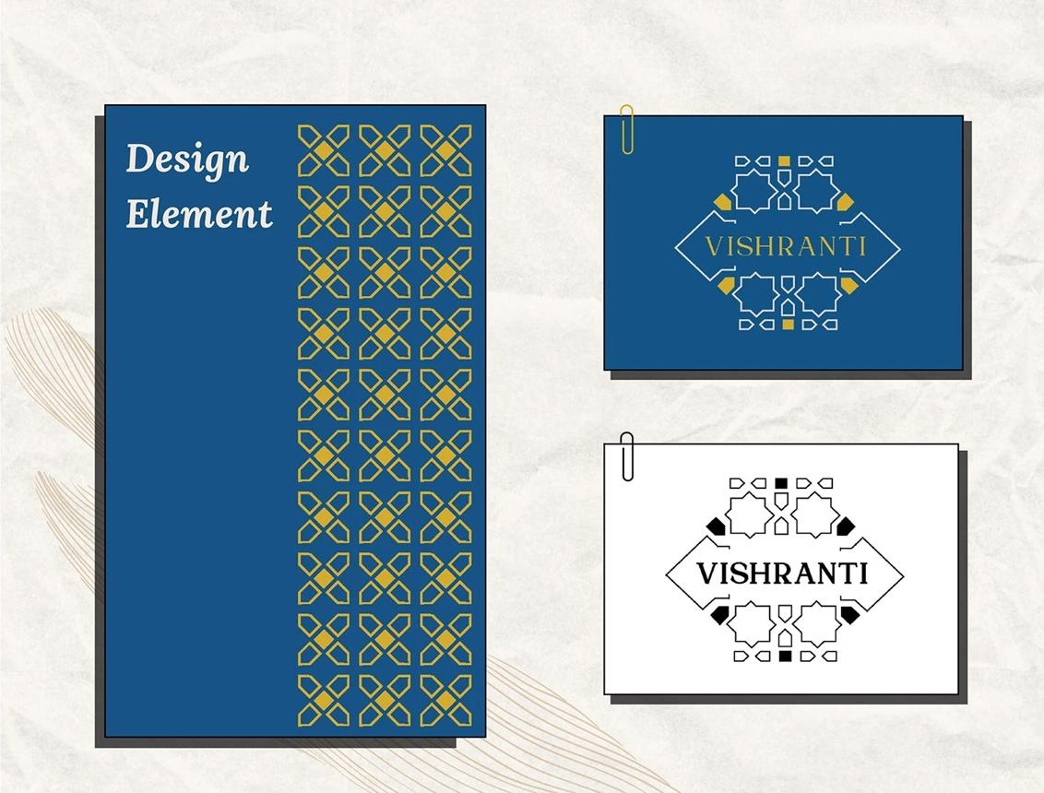
RANK #4

Indigo Knowledge Studio
Research-led, precise, contemporary
Strong trust cues

Colour palette
Mist
#F6F7F9
Pale blue
#DCE5F0
Indigo
#244A73
Ink navy
#182A40
Ochre
#B58A4A
Visual language: structured layouts, clear typographic hierarchy, source chips, evidence panels and restrained geometric motifs inspired by Indian textile and manuscript patterns.
Why it ranks fourth: this direction makes evidence and source inspection feel natural. It is particularly suitable for the AI Q&A experience. Its weakness is emotional warmth: an overly blue, structured system could feel like an academic database rather than an inviting discovery experience.
Best suited to: Q&A, source details, contested perspectives and research-heavy screens.
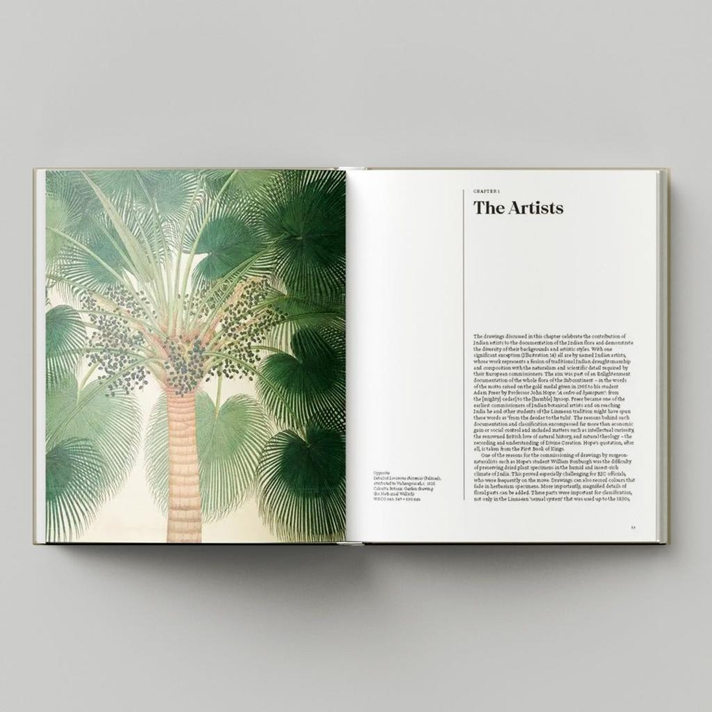
RANK #3

Living Culture
Organic, warm, human and rooted
Strong cultural identity

Colour palette
Ivory
#FAF6ED
Sage
#D9E1D1
Forest
#2F6251
Earth red
#B65D42
Muted gold
#D2B36C
Visual language: botanical and material references, textured imagery, rounded but disciplined cards, human-centred storytelling and subtle organic shapes.
Why it ranks third: it communicates continuity, ecology, craftsmanship and living traditions without relying entirely on monuments or religious iconography. The risk is that too much organic illustration or decorative texture could make the UI feel like a wellness or sustainable-lifestyle brand.
Best suited to: cultural practices, craft traditions, foodways, oral histories and community-centred stories.
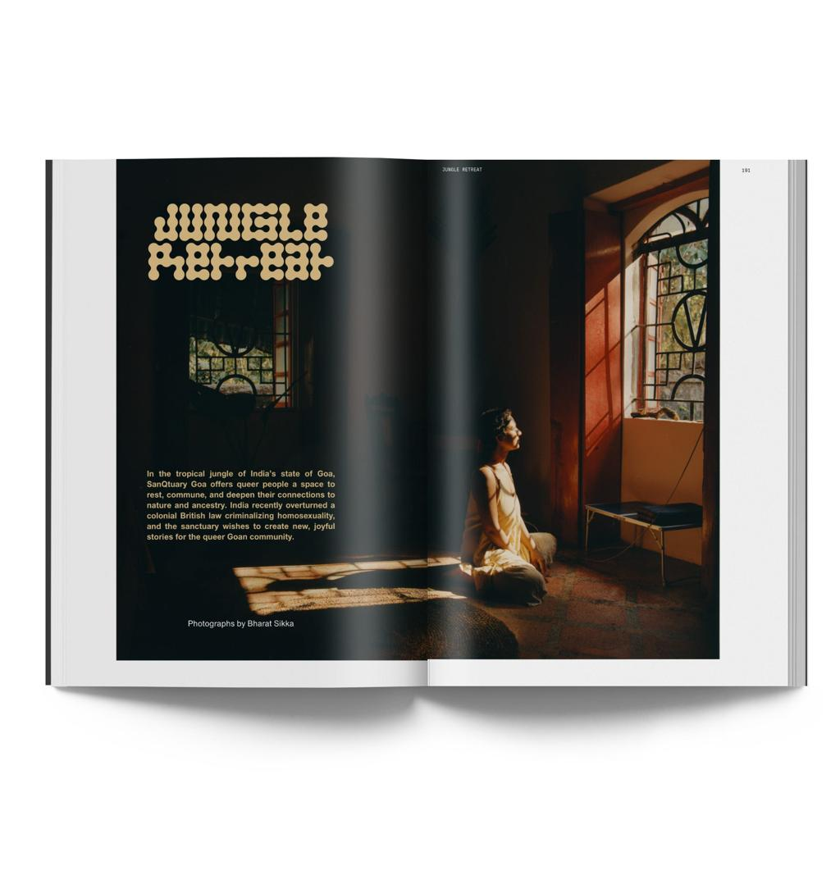
RANK #2

Cinematic Cultural Journal
Premium, immersive, emotionally compelling
High visual impact

Colour palette
Paper
#F5F0E7
Charcoal
#252521
Copper
#B96543
Deep red
#8C302D
Antique gold
#C9AA76
Visual language: large editorial images, bold titles, dramatic crops, sophisticated typography and cinematic transitions used sparingly.
Why it ranks second: it can make Indian culture feel contemporary, premium and worth exploring. It gives flagship stories a strong sense of occasion. The trade-off is readability and speed: dramatic imagery can overshadow evidence, and a dark cinematic UI is not automatically the best environment for long-form reading.
Best suited to: home-page hero sections, flagship story covers and high-impact discovery moments.
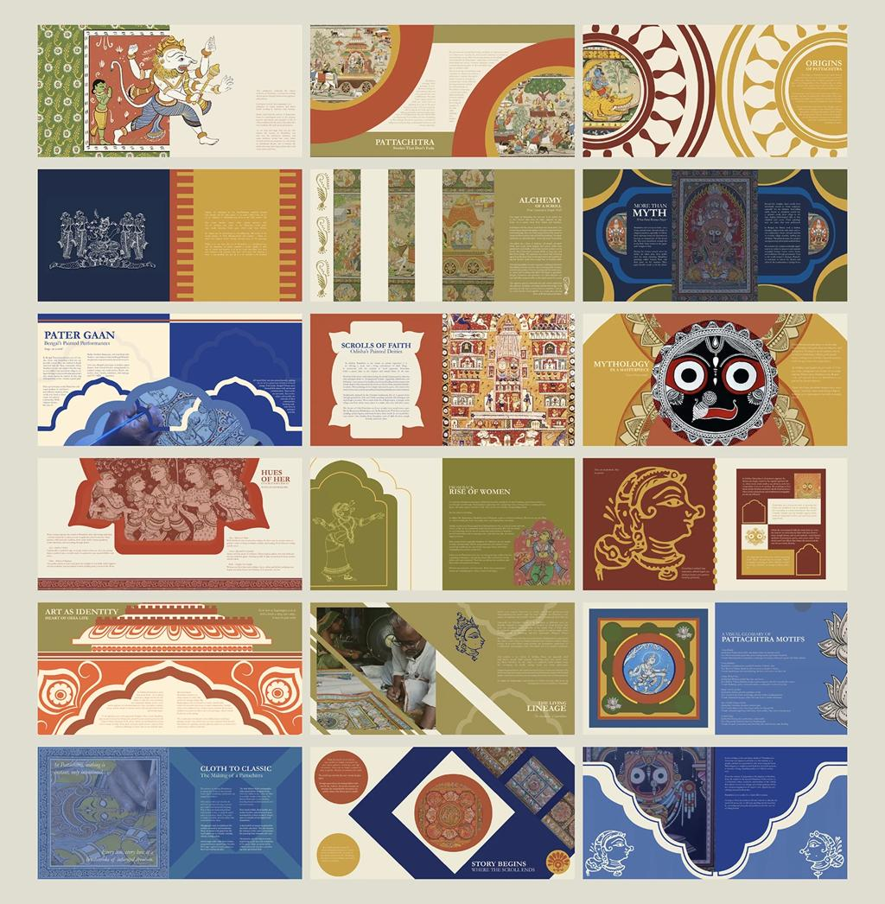
RANK #1 · RECOMMENDED

Living Editorial Atlas
Editorial depth + connected discovery + modern intelligence
Best overall fit

Colour palette
Warm paper
#F7F5EF
Stone
#E6E2D8
Forest
#245746
Terracotta
#B85E43
Charcoal
#2B3030
Muted gold
#D5B66F
Visual language: a warm editorial canvas, forest-green navigation and primary actions, restrained terracotta accents, generous typography, excellent cultural photography, visible source references and elegant relationship diagrams.
Why it ranks first: it balances the four things TattvaCo cannot afford to sacrifice: cultural richness, contemporary usability, trust and the desire to keep exploring. It can feel premium without being theatrical, scholarly without being cold, and Indian without turning the entire interface into a collection of cultural clichés.
Best suited to: the complete product, with cinematic treatments reserved for selected hero content and a research-led evidence system beneath it.

3. The design principles I would lock for TattvaCo
These principles should remain consistent regardless of which direction you choose. They draw on established practices such as Apple's hierarchy, harmony and consistency; Material Design's role-based colour systems; and Atlassian's typography, tokens and accessibility guidance.
Apple Developer Documentation
+2
Principle 1 — Editorial clarity over decoration
Headlines should spark curiosity; body text should be effortless to read. Use cultural imagery when it adds context, not as ornamental filler.
Principle 2 — Make relationships visible
Connections should be first-class interface elements, with clear explanations of why subjects relate. Avoid decorative node-and-line graphics that communicate nothing.
Principle 3 — Trust is part of the interface
Sources, evidence, conflicting interpretations and uncertainty must be discoverable at the point where a claim is presented.
Principle 4 — Progressive disclosure
Show a clear answer or narrative first. Let users open context, evidence and related perspectives when they want greater depth.
Principle 5 — Culture without cliché
Draw on India's diverse visual heritage through carefully selected photography, materials, typography and editorial art direction. Do not use saffron, mandalas, temple motifs or ornate borders as automatic shorthand for all Indian culture.
Principle 6 — Multilingual by design
Test all 11 launch languages for font coverage, line wrapping, card height, search behaviour and reading comfort. Avoid fixed-height text containers that truncate important content.
Principle 7 — Accessible by default
Target WCAG 2.2 AA contrast requirements: at least 4.5:1 for normal text and 3:1 for large text, with separate checks for interactive controls and non-text information.
W3C
+1

4. Recommended implementation foundation
My choice is Living Editorial Atlas, built with a structured design system rather than a collection of bespoke screens.
Design layer | Recommended starting point
Visual direction | Living Editorial Atlas
UI foundation | Tailwind CSS + shadcn/ui, consistent with the tentative technical stack
Design tokens | Semantic colour, typography, spacing, border, radius and elevation tokens
Typography | Editorial display face paired with a highly readable multilingual UI/body family
Colour | Warm-paper surfaces, forest-green primary actions, terracotta accents, charcoal text
Components | Story cards, connection cards, source panels, question composer, evidence labels, language selector
Responsive behaviour | Mobile-first layouts with wider reading and evidence panels on desktop
Quality checks | Keyboard access, screen-reader semantics, contrast tests, multilingual layout tests
These are recommendations, not confirmed brand or engineering decisions.

How I would allocate colour
- Warm paper: primary reading surfaces.
- Forest green: primary actions, active navigation and selected states.
- Terracotta: occasional editorial emphasis and discovery cues.
- Charcoal: body text and high-contrast headings.
- Muted gold: restrained decorative details, not small text on pale backgrounds.
- Semantic colours: separate accessible tokens for success, warning and error states; never rely on colour alone.
One important distinction: colour psychology is contextual, not universal. Green does not inherently make a product trustworthy, and terracotta does not inherently make it culturally authentic. The palette works only when the content, interactions and visual hierarchy reinforce the intended experience.

5. How to achieve a genuine 10/10 outcome
Do not choose a direction based only on which mockup looks most premium. Compare the five directions against the same four representative screens:
- Home / Discover.
- Flagship story detail.
- Ask TattvaCo answer with sources.
- Cultural connection detail.
Score each direction from 1–5 on:
- Brand distinctiveness.
- Readability and accessibility.
- Cultural richness without stereotyping.
- Trust and evidence visibility.
- Discovery and connection affordances.
- Multilingual adaptability.
- Mobile usability.
- Implementation simplicity.
Then test the leading two directions with representative culturally curious users. The winning design should help users understand what TattvaCo does, find a meaningful discovery, follow a connection and inspect the supporting evidence without assistance.
My final recommendation: use Living Editorial Atlas as the master visual system, borrow the cinematic storytelling of option #2 for selected editorial moments, and borrow the evidence clarity of option #4 for Q&A and source screens. Keep the overall interface light, readable and restrained.
That combination is the strongest starting hypothesis for TattvaCo—not a validated winner until tested with users.

TattvaCo UI Design System v1.0
Status: proposed design baseline · Platform: mobile-first responsive web · Scope: Phase 1 B2C cultural discovery

1. Brand identity
Design concept: Living Editorial Atlas
Brand personality: Curious, grounded, discerning, contemporary, culturally respectful and quietly premium.
Design promise: Every screen should help users move from curiosity to context, from context to evidence, and from evidence to a meaningful connection.

Visual identity rules
- Use editorial typography for cultural depth, not ornamental typography everywhere.
- Use photography to establish context, not as a substitute for explanation.
- Use green for primary interaction and navigation, not as a universal indicator of truth.
- Use terracotta for selected editorial emphasis, not every button or badge.
- Use diagrams only when the relationship they depict is explained and supported.
- Make evidence and uncertainty feel like native parts of the experience.

2. Colour tokens
The following palette is my recommended starting point for the design system.

Core palette
Canvas
#F7F5EF
Main app background
Surface
#FFFFFF
Cards, input fields and reading panels
Surface secondary
#EEECE4
Subtle grouping and secondary panels
Forest
#245746
Primary buttons, selected navigation and links
Forest hover
#1B4437
Hover and pressed primary actions
Terracotta
#B85E43
Editorial accents and occasional highlights
Charcoal
#2B3030
Headings and body text
Muted text
#5E6662
Secondary text and metadata
Border
#DCDDD4
Card borders and separators
Muted gold
#D5B66F
Decorative accents only

Semantic colours
Token | Proposed colour | Purpose
Success | #276749 | Successful operation
Warning | #8A5A12 | Review required or limitation
Error | #B42318 | Failed action or blocking error
Information | #285D80 | Neutral information
Evidence / context | Forest green + explicit label | Evidence-related content
Contested / uncertain | Warning treatment + explanatory text | Disagreement or limited evidence
These semantic colours are starting values, not certified accessible combinations. Test the actual foreground/background pairings before implementation. In particular, do not use muted gold for small text on the warm-paper background.

3. Typography system
The product needs two distinct typographic roles: editorial storytelling and functional interface text.
EDITORIAL DISPLAY · PROPOSED

Every story has a deeper context.
Use a refined serif for selected hero headlines and flagship story titles.
INTERFACE AND BODY · PROPOSED

Discover. Understand. Connect.
Use a highly legible sans-serif for navigation, buttons, labels, story body text, Q&A answers and source details.

Recommended type scale
Role | Desktop | Mobile
Display headline | 44–52 px | 32–36 px
Page title | 32 px | 28 px
Section heading | 24 px | 22 px
Card title | 18–20 px | 18 px
Body text | 17–18 px | 16–17 px
Supporting text | 14–15 px | 14 px
Metadata | 12–13 px | 12–13 px
Font selection approach: choose a serif and sans-serif pair with verified coverage for all 11 launch languages. Noto families are worth evaluating for broad script coverage, but do not assume one font will deliver ideal editorial typography in every script. Validate actual rendering, shaping, weights and line heights in Hindi, Kannada, Malayalam, Bengali, Tamil, Marathi, Telugu, Gujarati, Punjabi, Odia and English.
For long-form cultural content, prioritise reading comfort over fitting more words on the screen.

4. Spacing, shape and elevation
Use a consistent spacing scale based on multiples of four.

Spacing scale
4 px
8 px
12 px
16 px
24 px
32 px
40 px
48 px

Shape tokens
4–6 px
Small controls
10–12 px
Cards and fields
16 px
Feature panels
Use subtle borders as the default. Reserve shadows for floating menus, dialogs and genuinely elevated elements. Avoid making every card look like a separate floating tile.

Layout rules
- Mobile content padding: start at 20 px, then test 16 px on narrower devices.
- Desktop reading width: target approximately 680–760 px for long-form narrative.
- Buttons and important controls: target at least 44 × 44 CSS pixels where practical.
- Cards: allow variable height for translated text.
- Page sections: use whitespace to establish hierarchy, not decorative dividers everywhere.
- Avoid horizontal overflow at all supported widths.

5. Core component library
These are the reusable components I would build first. Each should have consistent variants, accessibility behaviour and responsive rules.

A. Primary and secondary buttons
Explore story See sources
Primary forest-green action, restrained outline secondary action, and text-only tertiary action. Every button needs hover, focus, pressed, disabled and loading states as appropriate.

B. Flagship story card

mindtrip.ai
CULTURAL STORY

Architecture as a living cultural record
Explore how a built space can reveal relationships between environment, craft, history and community.
Story · Sources · Connections
Components: optional image, editorial label, title, concise description and a clear destination. Do not invent ratings, popularity counts or reading-time claims.

C. Source and evidence panel

Sources & evidence
Claim: a specific statement made in the answer.
Supporting source: author or institution, title, date where available, and a direct link.
Evidence limitation: explain what the source supports and what remains uncertain.
Open source details
Use one shared source component across story pages and AI answers. This makes evidence inspection predictable.

D. Connection card

How these stories connect
Explain the relationship, why it matters and what evidence supports it.
Explore connection
Never show a bare graph edge as if visual proximity proves a cultural relationship. Every published connection needs a meaningful explanation.

E. Question composer
What are you curious about?
Ask about a tradition, a place, a historical claim or a cultural connection…
Answer in your selected language
Support multiline input, keyboard submission, disabled/loading states and recoverable failures. Keep the composer prominent without turning the entire home screen into a chat interface.

6. Screen-by-screen visual application
Screen | Visual treatment | Main design priority
Welcome / authentication | Warm canvas, concise editorial heading, simple form | Confidence and low-friction entry
Language selection | Clean list or grid, native-script labels | Readability and clear selection
Discover home | Prominent question composer, city and story cards | Curiosity and choice
City collection | Strong city heading, restrained contextual imagery | Orientation and browsing
Flagship story | Editorial title, narrow reading column, source panel | Comprehension and depth
Ask a question | Clean answer layout with visible source access | Usefulness and trust
Sources | Structured references and claim-level relationships | Evidence inspection
Connections | Relationship explanation, subject links and qualifications | Meaningful discovery
Continue discovering | Small, relevant set of related stories | Natural exploration without persistent personalisation
Shareable content | Direct content destination, compact branding | Continuity and accessibility
Report an issue | Simple accessible form | Clear feedback path
Settings | Plain list, clear labels | Control and transparency
AI/content states | Calm notices, explicit next action | Honest handling of uncertainty

7. Interaction states and motion
Use motion to clarify a change, not to make the product feel artificially intelligent.
- Navigation: quick, restrained transitions; preserve browser navigation conventions.
- Loading: a simple progress indicator and accurate status text such as “Exploring available sources…”.
- Connection exploration: highlight the selected relationship and reveal its explanation.
- Source inspection: use an accessible panel or dedicated page, chosen consistently.
- Errors: preserve the question or safe input where possible, and offer a retry.
- Reduced motion: respect the operating system's reduced-motion preference.
Avoid fake typing delays, decorative AI thinking animations that imply unsupported reasoning, and transitions that slow down reading.

8. Design-system acceptance checklist
Before treating this system as implementation-ready, evaluate it against these release criteria.

Readiness review
0/15 checked
Visual consistency
All screens use the same semantic colour tokens
Typography, spacing, radii and component variants are consistent
Primary and secondary actions are visually distinguishable
Cultural trust
Source references are accessible from stories and AI answers
Evidence, tradition and interpretation are distinguished where relevant
Connections explain their relationship and supporting evidence
Uncertainty and disagreement are represented honestly
Accessibility and languages
Text contrast and interactive states pass accessibility checks
Keyboard navigation and visible focus work
All 11 scripts render correctly
Translated content does not clip or break layouts
Responsive experience
Mobile screens have no unintended horizontal overflow
Desktop reading columns remain comfortable
Loading, empty, error and unavailable states are designed
Sharing and reporting behaviours have defined outcomes
Copy readiness checklist
The checklist is for design review; checking an item here does not independently verify that the product has passed that test.

9. Final design decision
My proposed baseline is:
- Visual direction: Living Editorial Atlas.
- Primary colour: Forest #245746.
- Background: Warm paper #F7F5EF.
- Editorial accent: Terracotta #B85E43.
- Typography: A culturally inclusive, multilingual type system with editorial display and readable interface/body styles.
- Layout: Mobile-first, editorial reading widths and progressive disclosure.
- Signature components: Flagship story cards, evidence panels, question composer and meaningful connection cards.
- Product signature: Every important discovery should help users understand not only what something is, but why it matters, what supports the explanation, and how it relates to something else.
This is the visual design baseline I recommend carrying into detailed screen design and frontend implementation. It is deliberately a proposed system: the next validation step is to apply it consistently to the Home, Story, Answer and Connection screens, then assess the experience with representative users before freezing the brand tokens.

